GABRIELS INTERVIEW PROJECT

**DATABASE CREATION:**

create database gabriels;

**TABLE CREATION:**

create table Details(UserId int primary key auto_increment,Username varchar(100),UserAddress nvarchar(100),UserPhone nvarchar(25),UserMail varchar(30),UserProfileImg longblob,DateUpdated datetime);

**TABLE DESCRIPTION:**

desc Details;

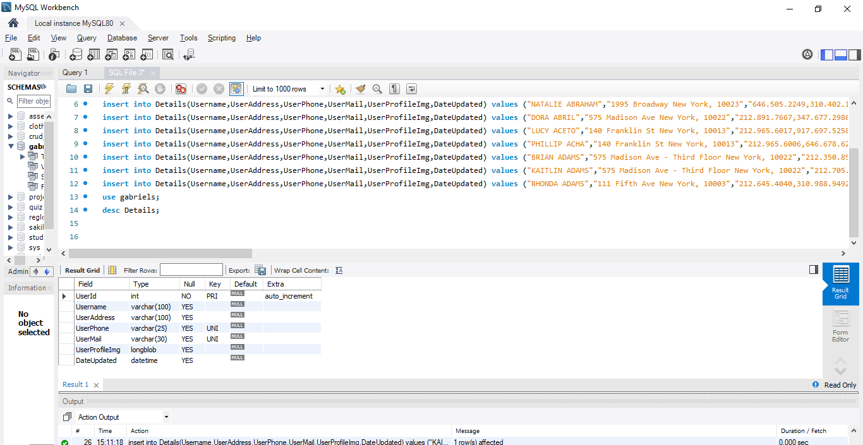

**Note:**

*(UserProfileImg=longblob)*

* Longblob field will accept **Local Directory Images and also Online URL Images**
* Image Binary conversion logic implement on ***views.py­­***

**INSERT DATA:**

insert into Details(Username,UserAddress,UserPhone,UserMail,UserProfileImg,DateUpdated) values ("JENNIFER (KAUFMAN) STILLMAN","575 Madison Ave New York, 10022","212.909.8464,917.584.6454","jennifer.stillman@elliman.com",load_file("C:/ProgramData/MySQL/MySQL Server 8.0/Uploads/03.jpeg"),now());

/* */

insert into Details(Username,UserAddress,UserPhone,UserMail,UserProfileImg,DateUpdated) values ("THE ZIV , GOTTLIEB, BERNSTEIN TEAM","111 Fifth Ave New York, 10003","212.337.6146,646.467.4694","Shai.Bernstein@elliman.com","",now());

/* */

insert into Details(Username,UserAddress,UserPhone,UserMail,UserProfileImg,DateUpdated) values ("THOMAS AABO","2488 Main St Bridgehampton, 11932","917.744.2937,917.744.2938","thomas.aabo@elliman.com",load_file("C:/ProgramData/MySQL/MySQL Server 8.0/Uploads/01.jpg"),now());

/* */

insert into Details(Username,UserAddress,UserPhone,UserMail,UserProfileImg,DateUpdated) values ("GABRIELLA ABDELNOUR","575 Madison Ave New York, 10022","212.891.7750,305.924.5080","gabdelnour@elliman.com","https://img-de-v2.gtsstatic.net/reno/imagereader.aspx?imageurl=https%3A%2F%2Fres.cloudinary.com%2Fdouglas-elliman%2Fimage%2Fupload%2Fw_800%2Fc_thumb%2Car_1%3A1%2Cg_face%2Fq_auto%3Abest%2FHeadShots%2F50%2Feqeevru0n9fbhoomsvna&option=N&idlisting=527-a-df23020912185265513&w=480&permitphotoenlargement=false&fallbackimageurl=https%3A%2F%2Fstatic-ind-elliman-newyorkcity-production-0.gtsstatic.net%2Fresources%2Fsiteresources%2Fcommonresources%2Fimages%2Fnophoto%2Fde_website_holder_450x450.jpg",now());

/* */

insert into Details(Username,UserAddress,UserPhone,UserMail,UserProfileImg,DateUpdated) values ("SILVIA ABOUD","","212.692.6182,212.692.6180","saboud@elliman.com","",now());

/* */

insert into Details(Username,UserAddress,UserPhone,UserMail,UserProfileImg,DateUpdated) values ("NATALIE ABRAHAM","1995 Broadway New York, 10023","646.505.2249,310.402.1891","natalie.abraham@elliman.com",load_file("C:/ProgramData/MySQL/MySQL Server 8.0/Uploads/02.jpg"),now());

/* */

insert into Details(Username,UserAddress,UserPhone,UserMail,UserProfileImg,DateUpdated) values ("DORA ABRIL","575 Madison Ave New York, 10022","212.891.7667,347.677.2986","dabril@elliman.com","https://img-de-v2.gtsstatic.net/reno/imagereader.aspx?imageurl=https%3A%2F%2Fres.cloudinary.com%2Fdouglas-elliman%2Fimage%2Fupload%2Fw_800%2Fc_thumb%2Car_1%3A1%2Cg_face%2Fq_auto%3Abest%2FHeadShots%2F50%2Fhtconkwydfpupt1sritn&option=N&idlisting=527-a-df1904101742526623218&w=480&permitphotoenlargement=false&fallbackimageurl=https%3A%2F%2Fstatic-ind-elliman-newyorkcity-production-2.gtsstatic.net%2Fresources%2Fsiteresources%2Fcommonresources%2Fimages%2Fnophoto%2Fde_website_holder_450x450.jpg",now());

/* */

insert into Details(Username,UserAddress,UserPhone,UserMail,UserProfileImg,DateUpdated) values ("LUCY ACETO","140 Franklin St New York, 10013","212.965.6017,917.697.5258","laceto@elliman.com","",now());

/* */

insert into Details(Username,UserAddress,UserPhone,UserMail,UserProfileImg,DateUpdated) values ("PHILLIP ACHA","140 Franklin St New York, 10013","212.965.6006,646.678.6203","phillip.acha@elliman.com","https://img-de-v2.gtsstatic.net/reno/imagereader.aspx?imageurl=https%3A%2F%2Fres.cloudinary.com%2Fdouglas-elliman%2Fimage%2Fupload%2Fw_800%2Fc_thumb%2Car_1%3A1%2Cg_face%2Fq_auto%3Abest%2FHeadShots%2F58%2Fitjjshl5n0khqcqknoon&option=N&idlisting=527-a-531-psa&w=480&permitphotoenlargement=false&fallbackimageurl=https%3A%2F%2Fstatic-ind-elliman-newyorkcity-production-2.gtsstatic.net%2Fresources%2Fsiteresources%2Fcommonresources%2Fimages%2Fnophoto%2Fde_website_holder_450x450.jpg",now());

/* */

insert into Details(Username,UserAddress,UserPhone,UserMail,UserProfileImg,DateUpdated) values ("BRIAN ADAMS","575 Madison Ave - Third Floor New York, 10022","212.350.8524,917.553.4453","badams@elliman.com","https://img-de-v2.gtsstatic.net/reno/imagereader.aspx?imageurl=https%3A%2F%2Fres.cloudinary.com%2Fdouglas-elliman%2Fimage%2Fupload%2Fw_800%2Fc_thumb%2Car_1%3A1%2Cg_face%2Fq_auto%3Abest%2FHeadShots%2F89%2Fqw9rzjeukmmsbq0nuion&option=N&idlisting=527-a-552-bsa&w=480&permitphotoenlargement=false&fallbackimageurl=https%3A%2F%2Fstatic-ind-elliman-newyorkcity-production-2.gtsstatic.net%2Fresources%2Fsiteresources%2Fcommonresources%2Fimages%2Fnophoto%2Fde_website_holder_450x450.jpg",now());

/* */

insert into Details(Username,UserAddress,UserPhone,UserMail,UserProfileImg,DateUpdated) values ("KAITLIN ADAMS","575 Madison Ave - Third Floor New York, 10022","212.705.1070,858.945.2489","kladams@elliman.com","https://img-de-v2.gtsstatic.net/reno/imagereader.aspx?imageurl=https%3A%2F%2Fres.cloudinary.com%2Fdouglas-elliman%2Fimage%2Fupload%2Fw_800%2Fc_thumb%2Car_1%3A1%2Cg_face%2Fq_auto%3Abest%2FHeadShots%2F89%2Fzmx8spnct8qnvifybcrm&option=N&idlisting=527-a-df18031508575265524&w=480&permitphotoenlargement=false&fallbackimageurl=https%3A%2F%2Fstatic-ind-elliman-newyorkcity-production.gtsstatic.net%2Fresources%2Fsiteresources%2Fcommonresources%2Fimages%2Fnophoto%2Fde_website_holder_450x450.jpg",now());

/* */

insert into Details(Username,UserAddress,UserPhone,UserMail,UserProfileImg,DateUpdated) values ("RHONDA ADAMS","111 Fifth Ave New York, 10003","212.645.4040,310.988.9492","rhonda.adams@elliman.com","https://img-de-v2.gtsstatic.net/reno/imagereader.aspx?imageurl=https%3A%2F%2Fres.cloudinary.com%2Fdouglas-elliman%2Fimage%2Fupload%2Fw_800%2Fc_thumb%2Car_1%3A1%2Cg_face%2Fq_auto%3Abest%2FHeadShots%2F77%2Fuwyzqlsuoupgchc0bkud&option=N&idlisting=527-a-531-rhona&w=480&permitphotoenlargement=false&fallbackimageurl=https%3A%2F%2Fstatic-ind-elliman-newyorkcity-production-3.gtsstatic.net%2Fresources%2Fsiteresources%2Fcommonresources%2Fimages%2Fnophoto%2Fde_website_holder_450x450.jpg",now());